**Project Description**

The objective of this project is to streamline the web application development lifecycle by implementing automation through Jenkins and GitHub. Through seamless integration with GitHub webhooks, the Jenkins pipeline will initiate automatically upon code repository modifications. The pipeline will encompass key stages including application building, testing, and deployment.

**Log into AWS and Create an EC2 Instance**

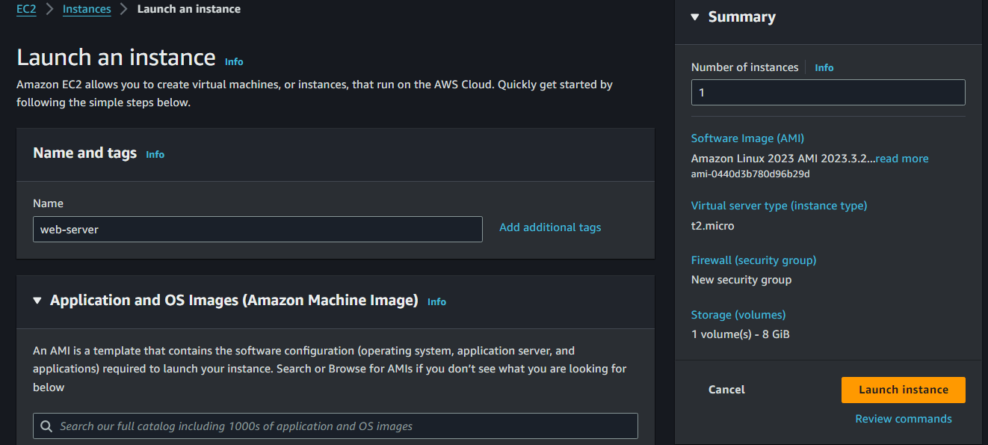

**Connect to the EC2 Instance**

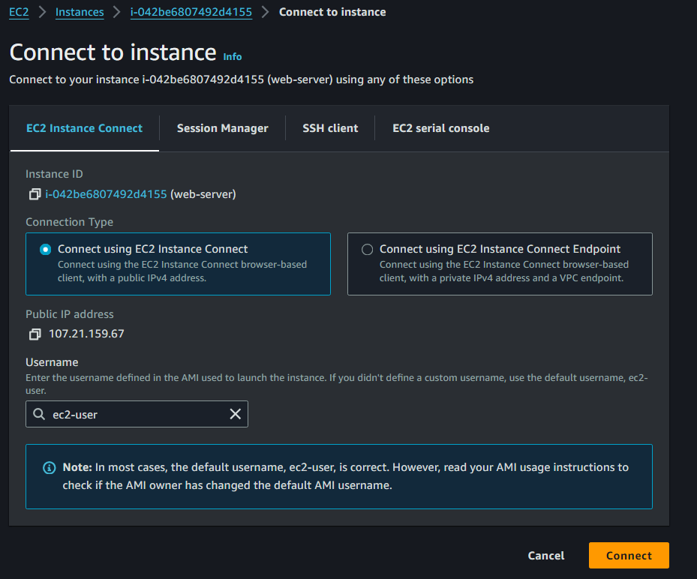

**Downloading and Installing Jenkins**

sudo yum update –y

sudo wget -O /etc/yum.repos.d/jenkins.repo \

https://pkg.jenkins.io/redhat-stable/jenkins.repo

sudo rpm --import https://pkg.jenkins.io/redhat-stable/jenkins.io-2023.key

sudo yum upgrade

sudo dnf install java-17-amazon-corretto -y

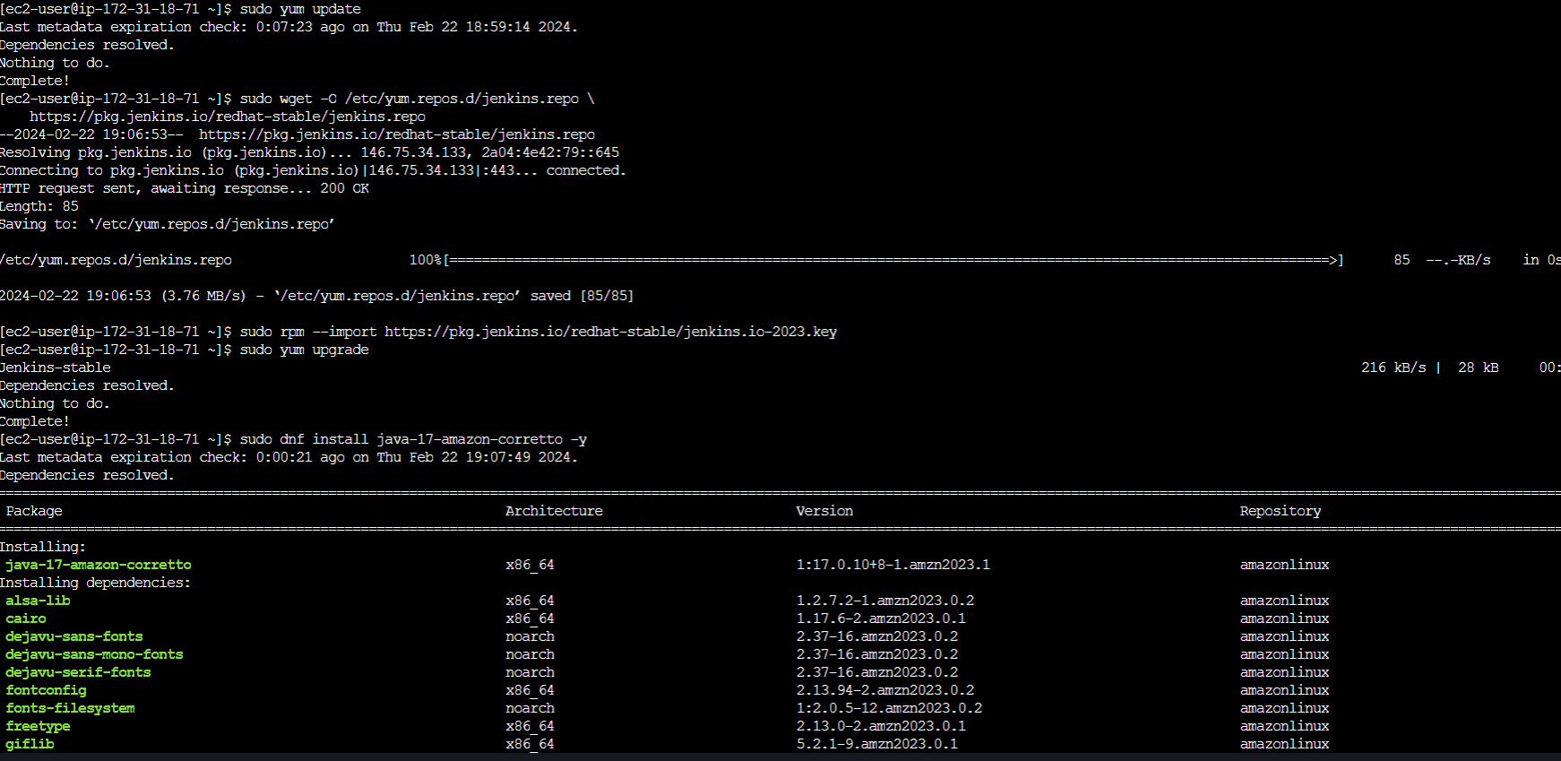

**Install Jenkins**

sudo yum install jenkins -y

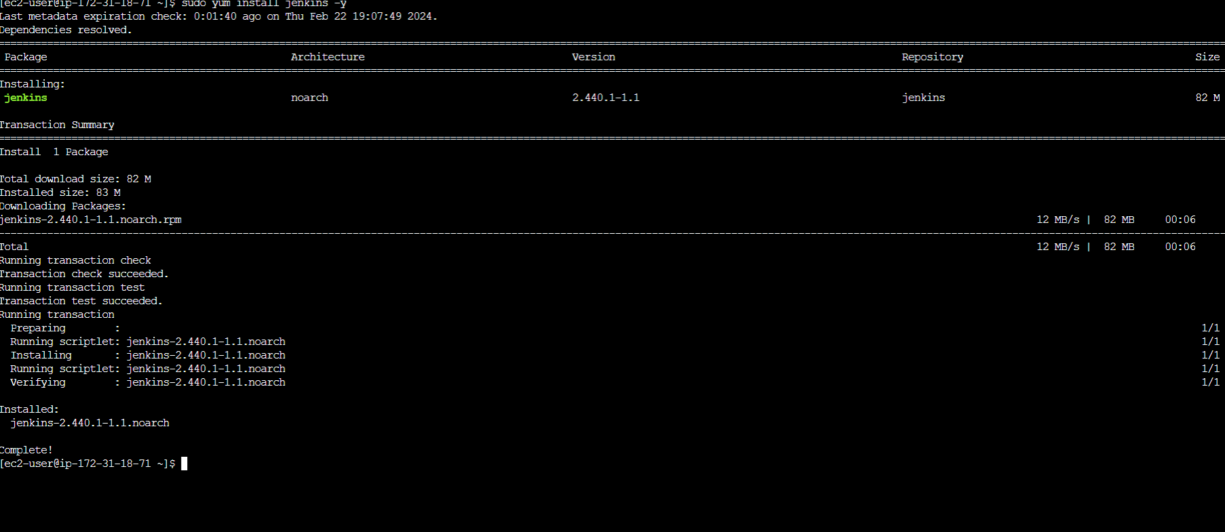

**Enable and Start Jenkins**

sudo systemctl enable Jenkins

sudo systemctl start jenkins

sudo systemctl status jenkins

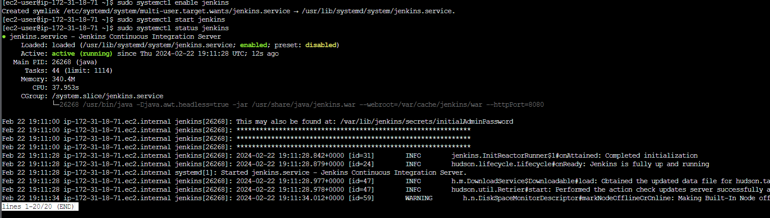

**Install Docker**

sudo yum install docker -y

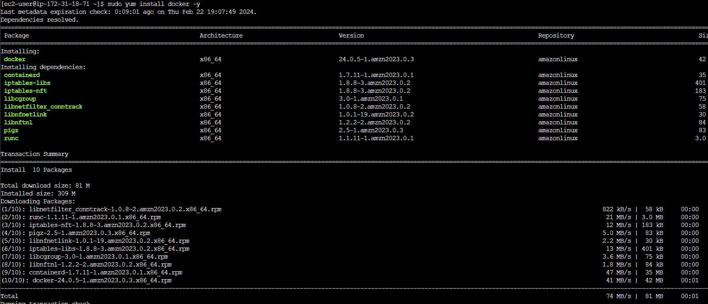

**Start Docker**

sudo systemctl start docker

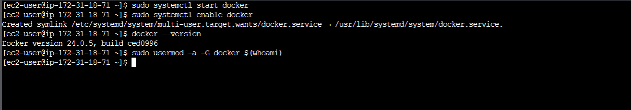

**Generate the SSH keys for integrating your Jenkins project with your git repository**

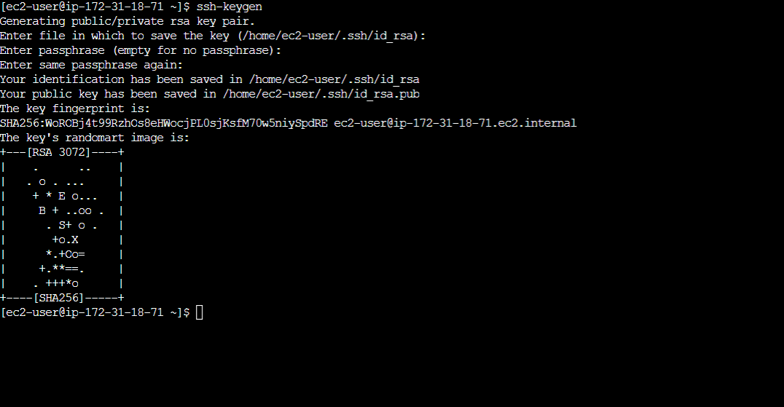

**Allow traffic for Jenkins by adding the port number in Security group**

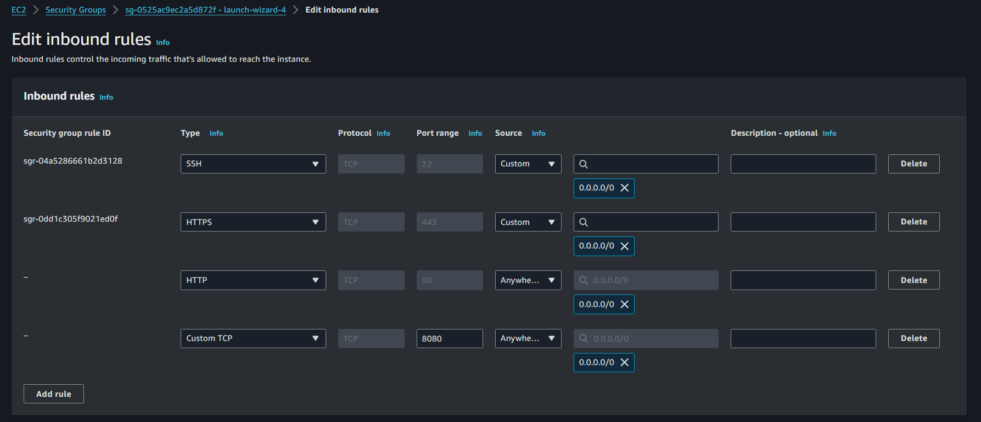

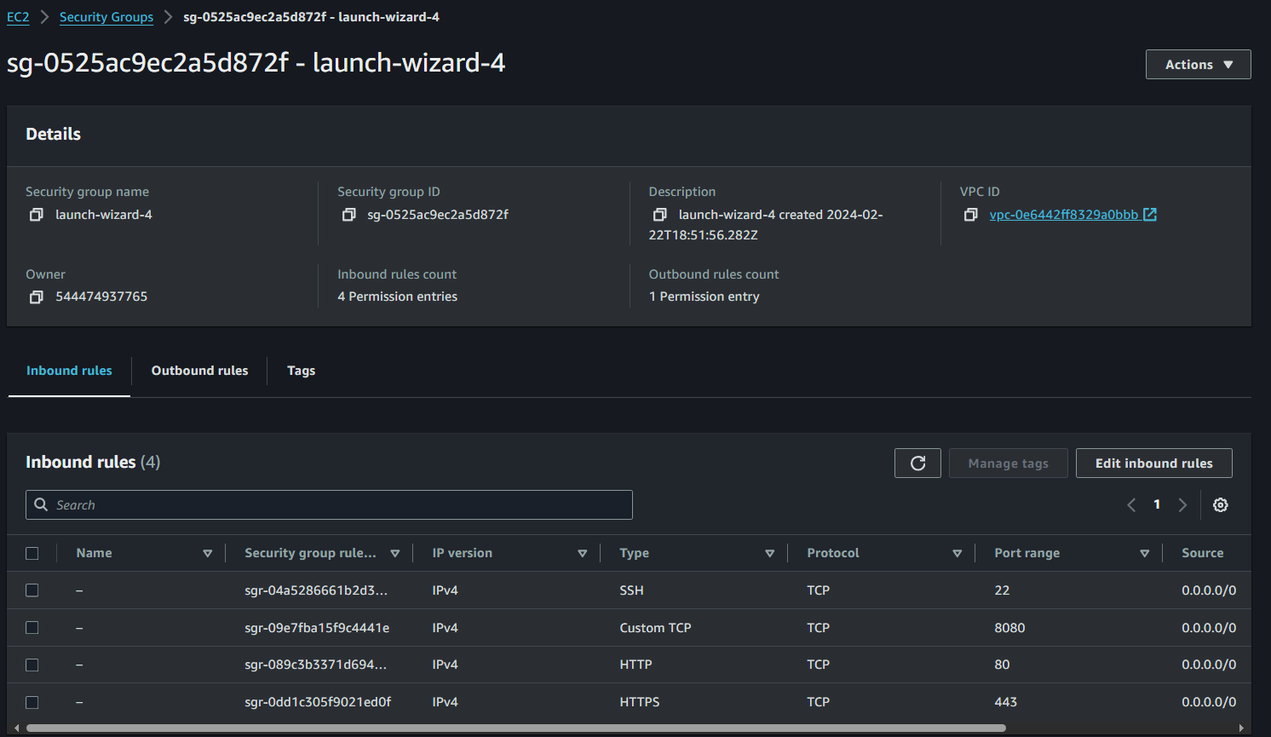

**Jenkins Configuration**

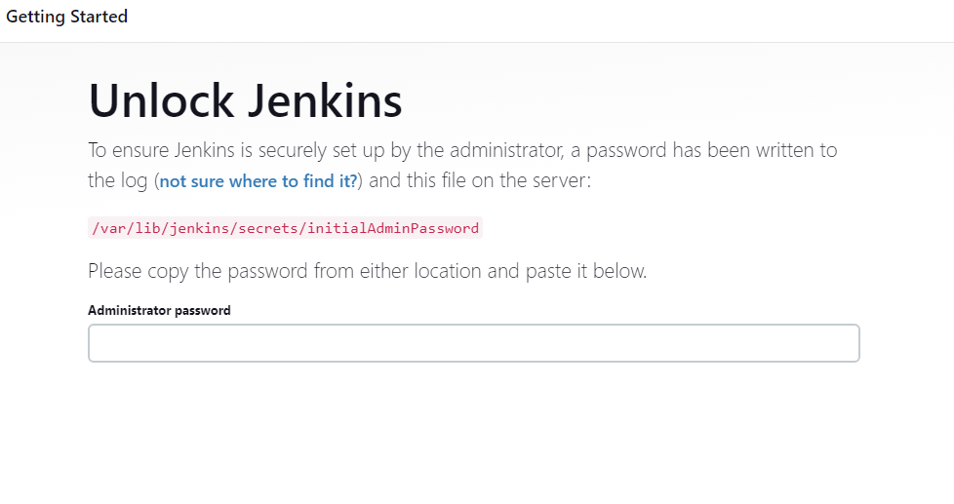

cat /var/lib/jenkins/secrets/initialAdminPassword

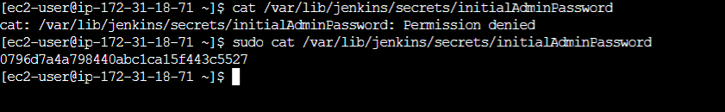

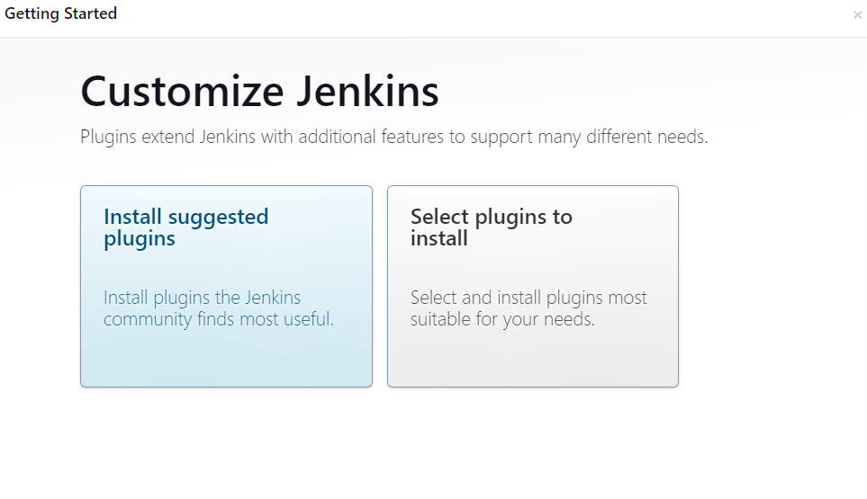

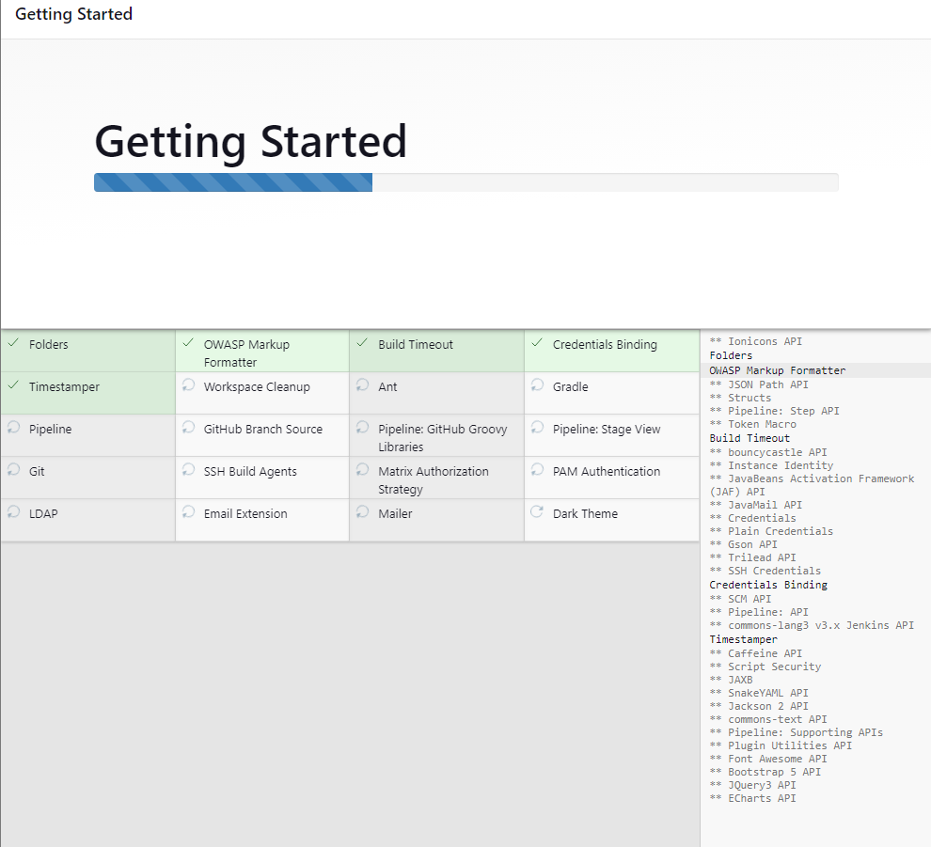

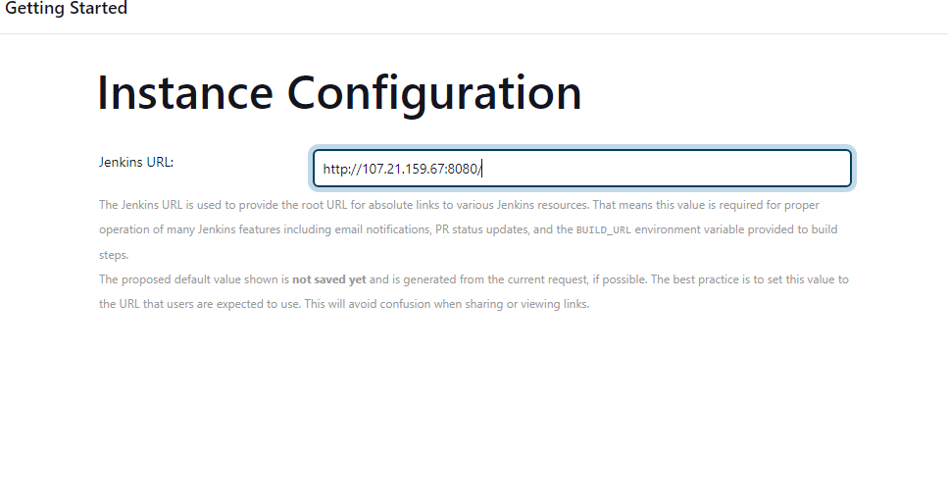

**Create Freestyle Project**

